No warranties, express or implied are given by CDC with respect to accuracy, reliability, quality, correctness, or freedom from error or omission of this work product, including any implied warranties of merchantability, fitness for a specific purpose or non-infringement. This document is delivered "as is", and CDC shall not be liable for any inaccuracy thereof. CDC does not warrant that all errors in this work product shall be corrected. Except as expressly set forth in any master services agreement or project assignment, CDC is not assuming any obligations or liabilities including but not limited to direct, indirect, incidental or consequential, special or exemplary damages resulting from the use of or reliance upon any information in this document. This document does not imply an endorsement of any of the companies or products mentioned.

©2021 CDC. All rights reserved. No part of this document may be reproduced, copied or modified without the express written consent of the authors. Unless written permission is expressly granted for other purposes, this document shall be treated at all times as the confidential and proprietary material of CDC and may not be distributed or published to any third-party.

شركة شل

From 29-09-2021 to 05-10-2021

Findings

Network

|  |  |  |  |
| --- | --- | --- | --- |
| Title | Status | ID | Risk |
| Slow HTTP Denial of Service Attack | WAITING | undefined | Critical |

Web

|  |  |  |  |
| --- | --- | --- | --- |
| Title | Status | ID | Risk |

**NETWORK**



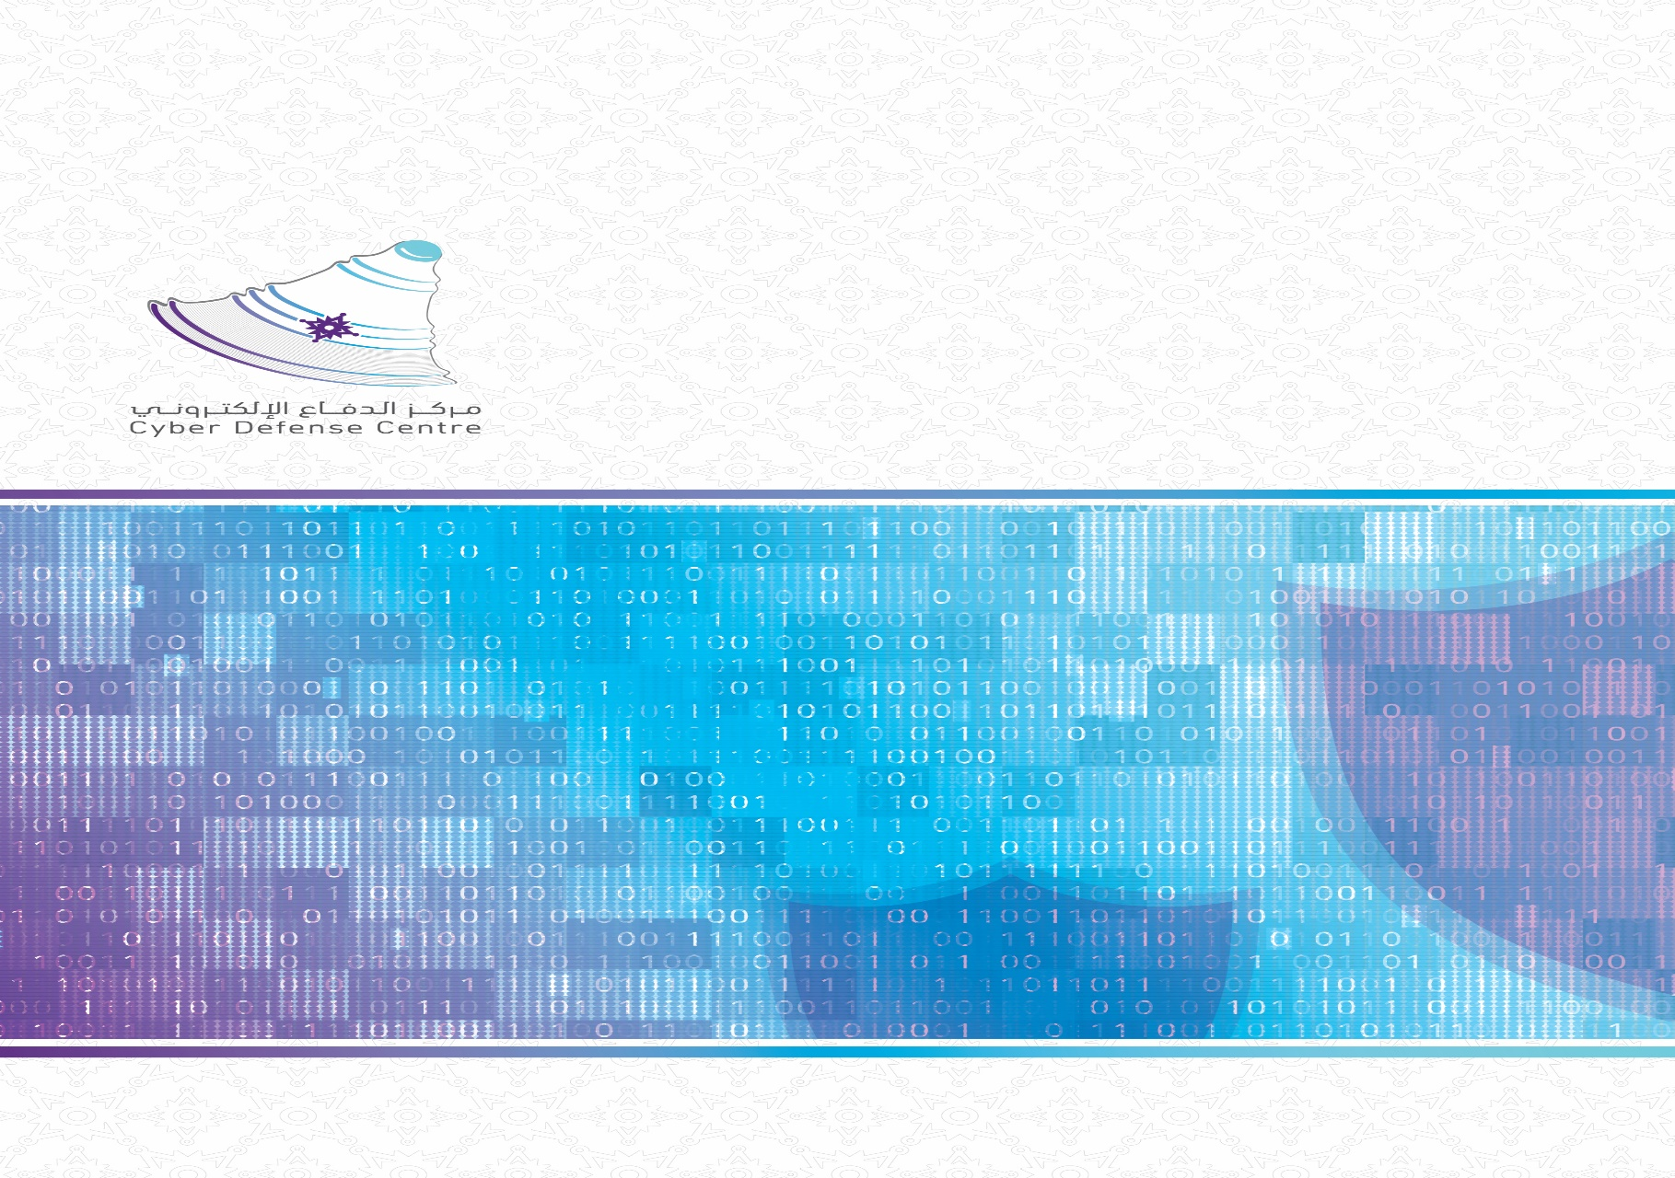

|  |  |  |  |
| --- | --- | --- | --- |
| Critical | |  | |
|  | 1 - Slow HTTP Denial of Service Attack | | (4 days) to fix |

The web server is vulnerable to Slow HTTP DoS (Denial of Service) attacks.
Slowloris and Slow HTTP POST DoS attacks rely on the fact that the HTTP protocol, by design, requires requests to be completely received by the server before they are processed. If an HTTP request is not complete, or if the transfer rate is very low, the server keeps its resources busy waiting for the rest of the data. If the server keeps too many resources busy, this creates a denial of service.The impact of this vulnerabilityA single machine can take down another machines web server with minimal bandwidth and side effects on unrelated services and ports.

Affected IPs

sfghsgfh

Recommendation

Consult Web references for information about protecting your web server against this type of attack.

Reference

https://www.funtoo.org/Slowloris_DOS_Mitigation_Guidehttps://web.archive.org/web/20180329210925/http://blog.secaserver.com/2011/08/protect-apache-slowloris-attack/

Evidence